**POWER CONSUMPTION ANALYSIS FOR HOUSEHOLDS Final Project Report**

1. Introduction
   1. Project overviews
   2. Objectives
2. Project Initialization and Planning Phase
   1. Define Problem Statement
   2. Project Proposal (Proposed Solution)
   3. Initial Project Planning
3. Data Collection and Preprocessing Phase
   1. Data Collection Plan and Raw Data Sources Identified
   2. Data Quality Report
   3. Data Exploration and Preprocessing
4. Model Development Phase
   1. Feature Selection Report
   2. Model Selection Report
   3. Initial Model Training Code, Model Validation and Evaluation Report
5. Model Optimization and Tuning Phase
   1. Hyperparameter Tuning Documentation
   2. Performance Metrics Comparison Report
   3. Final Model Selection Justification
6. Results
   1. Output Screenshots
7. Advantages & Disadvantages
8. Conclusion
9. Future Scope
10. Appendix
    1. Source Code
    2. GitHub & Project Demo Link

**1.INTRODUCTION**

**1.1 Project overview**

The project aims to analyze power consumption patterns in households to provide insights for energy efficiency and cost-saving measures. By analyzing historical power consumption data along with other relevant factors such as weather conditions, occupancy patterns, and appliance usage, the project seeks to identify trends and patterns that can help households optimize their energy usage.

**1.2 Objectives**

**Energy Consumption Pattern Identification**

The project analyzes historical power consumption data to identify patterns in energy usage, such as peak usage times, seasonal variations, and the impact of weather conditions. This information can help households adjust their energy usage to reduce costs.

**Cost-Saving Recommendations**

Based on the analysis of power consumption patterns and appliance efficiency, the project provides recommendations to households on how to reduce their energy consumption and save costs. This could include tips on adjusting thermostat settings, using appliances during off-peak hours, or investing in energy-efficient appliances.

**2. Project Initialization and Planning Phase**

**2.1 Define Problem Statement**

A household concerned with energy efficiency and cost savings wants to optimize the power consumption to reduce electricity bills, posing a challenge lacking the necessary knowledge and tools to monitor and analyze energy usage effectively.

**2.2 Project Proposal (Proposed solution)**

* The proposed project, "Power Consumption Analysis for Households," aims to leverage machine learning for more accurate power consumption predictions.
* Using a comprehensive dataset including global active power, reactive power, global intensity, voltage, submetering readings, the project seeks to develop a predictive model for optimizing the power consumption.
* This initiative aligns with the Power consumption analysis objective to provide insights for energy efficiency and cost-saving measures and provides recommendations to households on how to reduce their energy consumption and save costs.

**2.3 Initial Project Planning**

* Initial Project Planning involves outlining key objectives, defining scope, and identifying the power consumption patterns.
* It encompasses setting timelines, allocating resources, and determining the overall project strategy.

**3. Data Collection and Preprocessing Phase**

**3.1 Data Collection Plan and Raw Data Sources Identified**

* The dataset for "Power Consumption Analysis for Households" is sourced from Kaggle.
* It includes detailed measurements taken over time.
* Date: Date in format dd/mm/yyyy
* Time: time in format hh:mm:ss
* Global_active_power: household global minute-averaged active power (in kilowatt)
* Global_reactive_power: household global minute-averaged reactive power (in kilowatt)
* Voltage: minute-averaged voltage (in volt)
* Global_intensity: household global minute-averaged current intensity (in ampere)
* Sub_metering_1: energy sub-metering No. 1 (in watt-hour of active energy). It corresponds to the kitchen, containing mainly a dishwasher, an oven and a microwave (hot plates are not electric but gas powered).
* Sub_metering_2: energy sub-metering No. 2 (in watt-hour of active energy). It corresponds to the laundry room, containing a washing-machine, a tumble-drier, a refrigerator and a light.
* Sub_metering_3: energy sub-metering No. 3 (in watt-hour of active energy). It corresponds to an electric water-heater and an air-conditioner.

**3.2 Data Quality Report**

* Data quality is ensured through thorough verification, addressing missing values, and maintaining adherence to ethical guidelines, establishing a reliable foundation for predictive modeling.

**3.3 Data Exploration and preprocessing**

* Data Exploration involves analyzing the household power consumption dataset to understand patterns, distributions, and outliers.
* Preprocessing includes handling missing values, scaling, and encoding categorical variables.
* These crucial steps enhance data quality, ensuring the reliability and effectiveness of subsequent analysis.

**4. Model Development Phase**

**4.1 Feature Selection Report**

* The Feature Selection Report outlines the rationale behind choosing specific features (e.g., Global reactive power, global intensity, submetering readings) for the power consumption prediction model.
* It evaluates relevance, importance, and impact on predictive accuracy, ensuring the inclusion of key factors influencing the model's ability.

**4.2 Model Selection Report**

* The Model Selection Report details the rationale behind choosing Linear Regression, Random Forest, Decision Tree, and XGB models for power consumption prediction.
* It considers each model's strengths in handling complex relationships, interpretability, adaptability, and overall predictive performance, ensuring an informed choice aligned with project objectives.

**4.3 Initial Model Training Code, Model Validation and Evaluation Report**

* The Initial Model Training Code employs selected algorithms on the household power consumption dataset, setting the foundation for predictive modeling.
* The subsequent Model Validation and Evaluation Report rigorously assesses model performance, employing metrics like Mean Absolute Error (MAE), Mean Squared Error (MSE), Root Mean Squared Error (RMSE), R-squared error to ensure reliability and effectiveness in predicting power consumption outcomes.

**5.Model Optimization and Tuning Phase**

**Final Model Selection Justification**

* The XGBoost Regressor is the final model chosen because of its best overall performance compared to the other models.
* It captures the variance in the data very well with minimal prediction error. XGBoost can capture complex non-linear relationships.

**6. RESULTS**

**6.1 Output Screenshots**

**PCA.HTML**

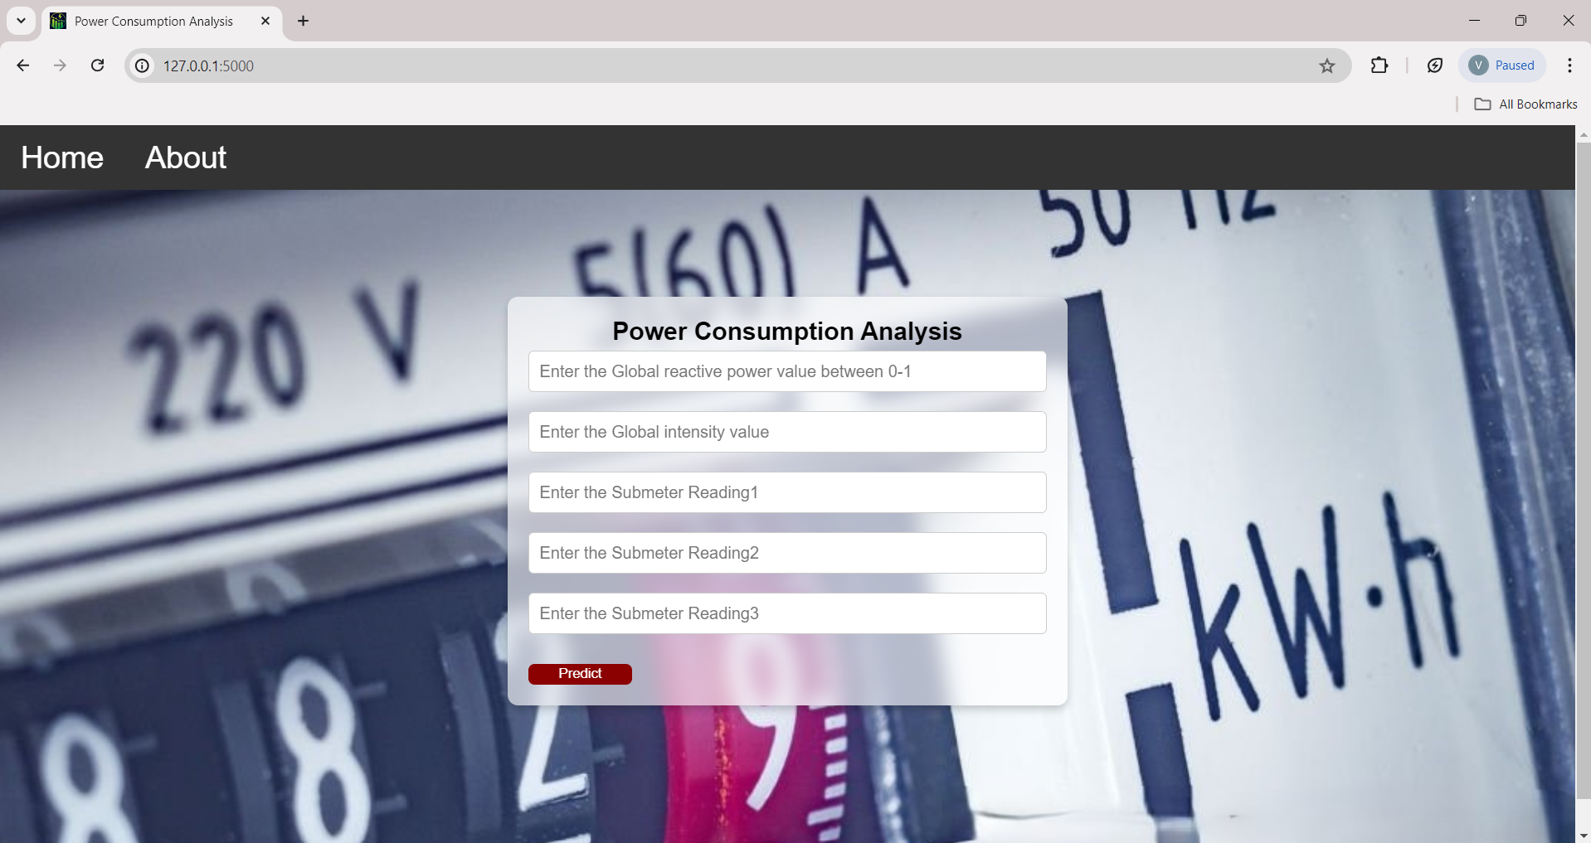**HOME PAGE**

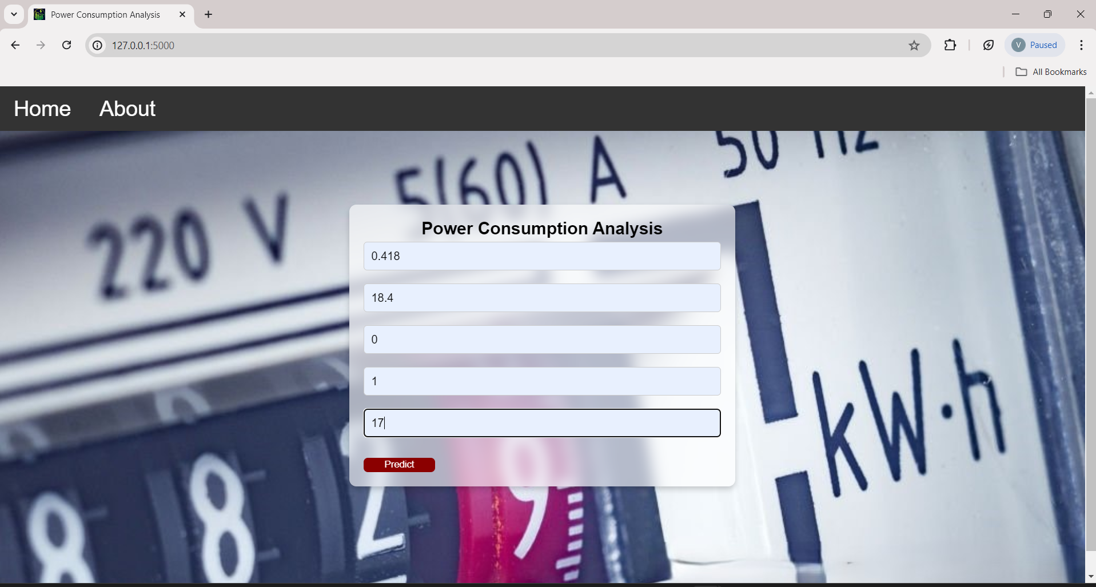

**OUTPUT PAGE**

RESULT.HTML

**7. Advantages and disadvantages**

## 7.ADVANTAGES AND DISADVANTAGES

**Advantages:**

1. **Insight into Usage Patterns**: Power consumption analysis provides detailed insights into how energy is used within households, identifying peak usage times, high-consumption appliances, and areas of potential energy efficiency improvements.
2. **Cost Savings**: By understanding energy usage patterns, households can implement strategies to reduce consumption during peak hours or adjust usage behaviors, leading to lower utility bills over time.
3. **Environmental Impact**: Efficient energy management reduces carbon footprint and environmental impact associated with energy production and consumption, contributing to sustainability efforts.
4. **Smart Decision Making**: Data-driven insights enable informed decision-making regarding appliance upgrades, energy-efficient investments, and behavioural changes that optimize energy use.
5. **Behavioural Changes**: Awareness of energy consumption encourages households to adopt energy-saving habits and practices, promoting a culture of sustainability and conservation.

**Disadvantages:**

1. **Cost of Implementation**: Initial costs associated with installing smart meters or acquiring advanced energy monitoring systems may be prohibitive for some households, especially in low-income areas.
2. **Privacy Concerns**: Continuous monitoring of energy usage raises privacy concerns regarding data collection, storage, and potential misuse of personal information.
3. **Technical Complexity**: Analysing and interpreting energy data requires technical expertise and resources, which may be challenging for households without access to specialized knowledge or support.
4. **Resistance to Change**: Some households may be resistant to adopting new technologies or changing energy consumption behaviours, hindering the effectiveness of energy-saving initiatives.
5. **Data Accuracy and Reliability**: Issues such as metering inaccuracies or data transmission errors can affect the reliability and validity of consumption data, impacting the accuracy of analysis and recommendations.

**8.Conclusion**

* In conclusion, the analysis of power consumption in households through advanced monitoring and data analytics presents significant opportunities for optimizing energy usage and promoting sustainability. This project has demonstrated the effectiveness of smart metering technology coupled with sophisticated data analysis techniques in providing detailed insights into household energy consumption patterns. By capturing real-time data and applying statistical analysis and machine learning algorithms, the project has identified peak usage times, inefficient practices, and opportunities for improvement.

## 9. FUTURE SCOPE

* + **Integration of IoT and Smart Home Technologies**: The integration of Internet of Things (IoT) devices and smart home technologies with power consumption analysis systems will enable more granular data collection and real-time monitoring. Smart appliances, energy management systems, and home automation platforms will work synergistically to optimize energy usage and enhance user convenience.
  + **Advanced Data Analytics and AI**: Future advancements in data analytics, machine learning, and artificial intelligence (AI) will enable more sophisticated analysis of energy consumption patterns. Predictive analytics models can forecast energy demand, identify anomalies, and offer proactive recommendations for optimizing energy efficiency based on historical and real-time data.
  + **Demand Response Programs**: Increased participation in demand response programs facilitated by power consumption analysis systems will enable households to adjust their electricity usage in response to grid conditions and time-varying electricity prices. This not only benefits individual consumers by reducing costs during peak demand periods but also supports grid stability and reliability.
  + **Energy Management Platforms**: Development of comprehensive energy management platforms that integrate power consumption analysis with energy generation (such as solar panels) and storage solutions (like batteries) will empower households to achieve greater energy independence and resilience. These platforms will enable optimal energy allocation, self-consumption optimization, and participation in energy markets.
  + **Global Adoption and Standardization**: Increasing global adoption of power consumption analysis technologies will drive economies of scale, reducing costs and improving accessibility for households worldwide. Standardization of measurement methodologies and data formats will facilitate interoperability and compatibility across different systems and regions.

**10.Appendix**

**10.1. Source Code**

**Code Snippets**

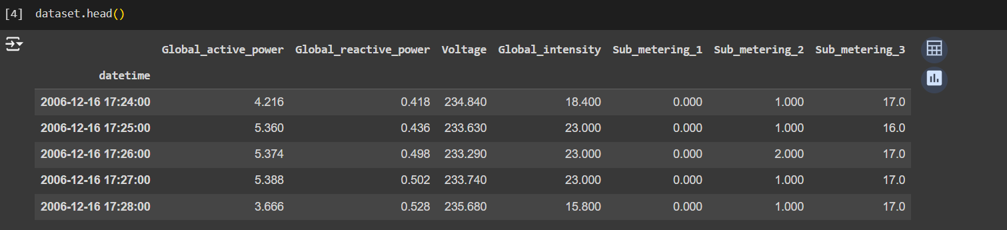

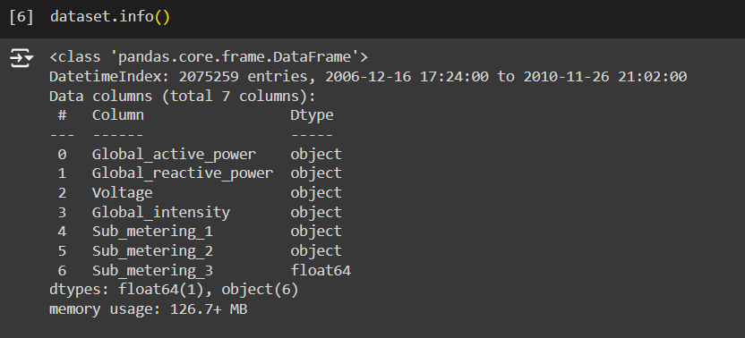



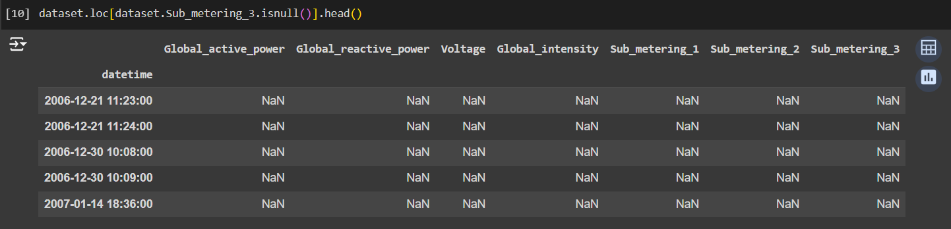



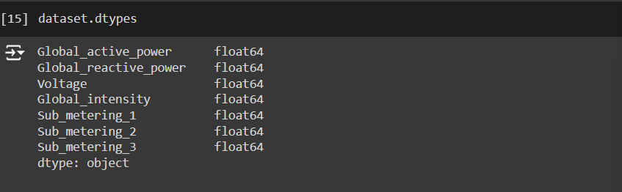

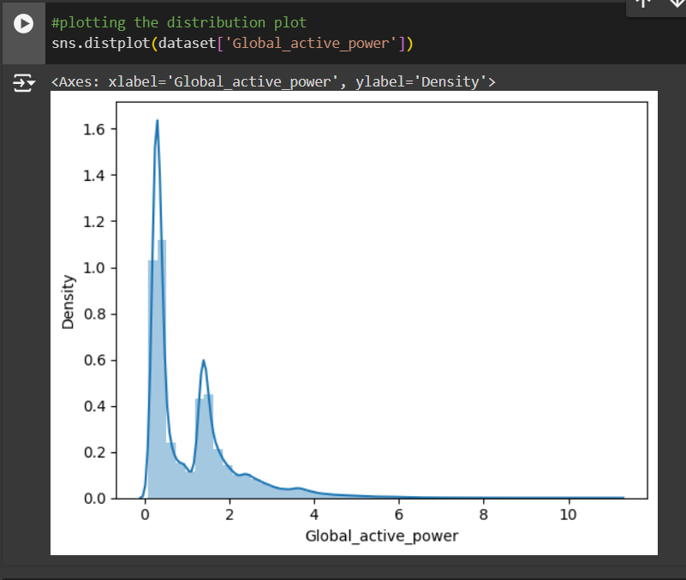

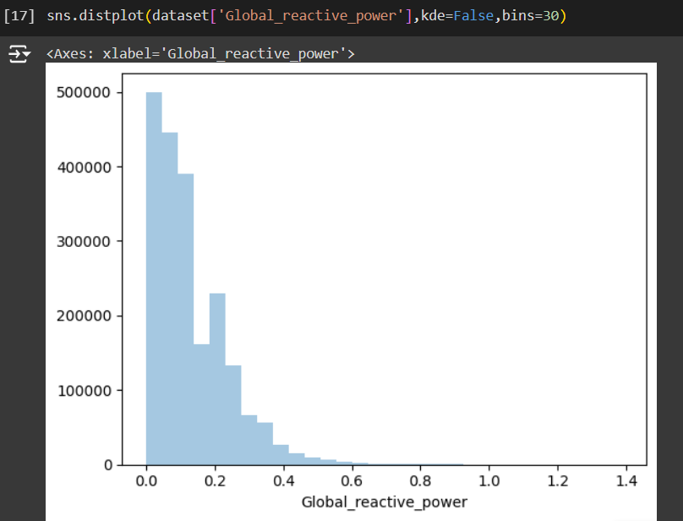

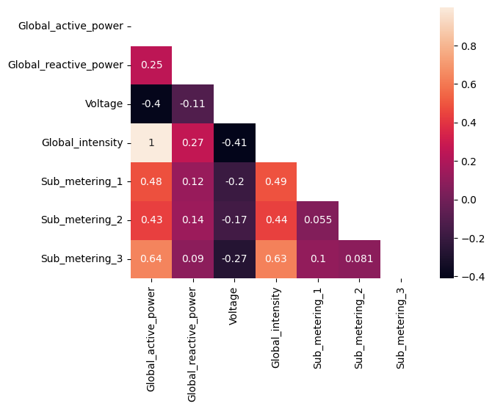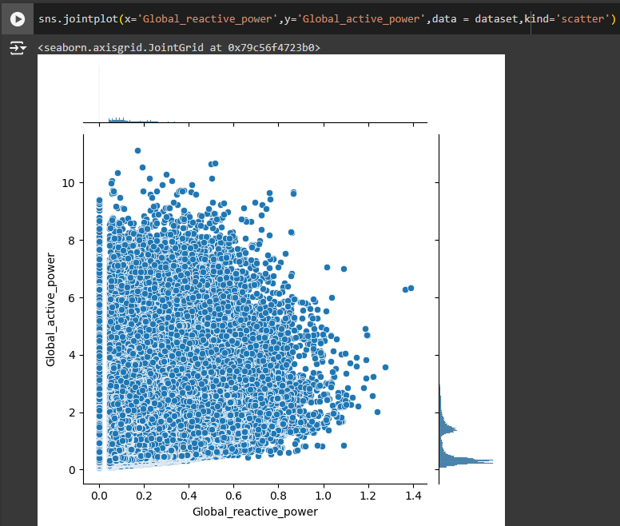

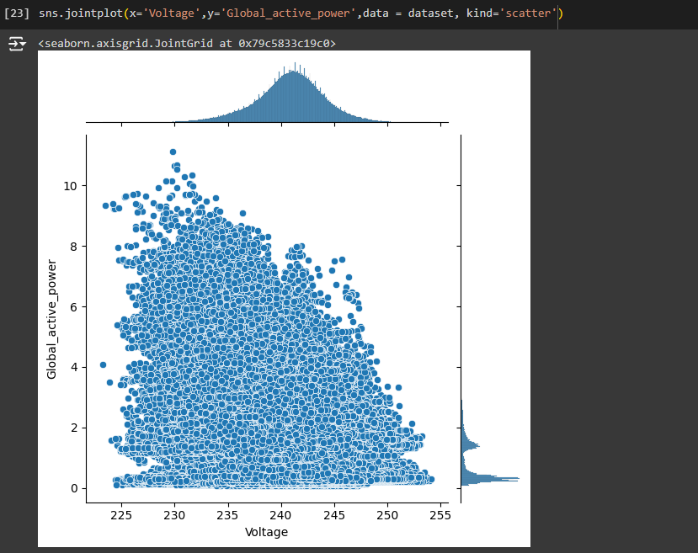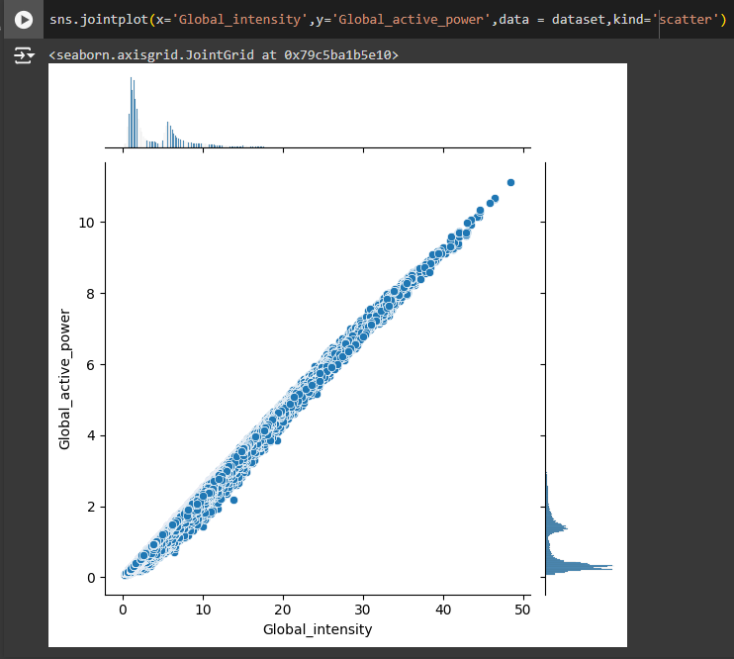

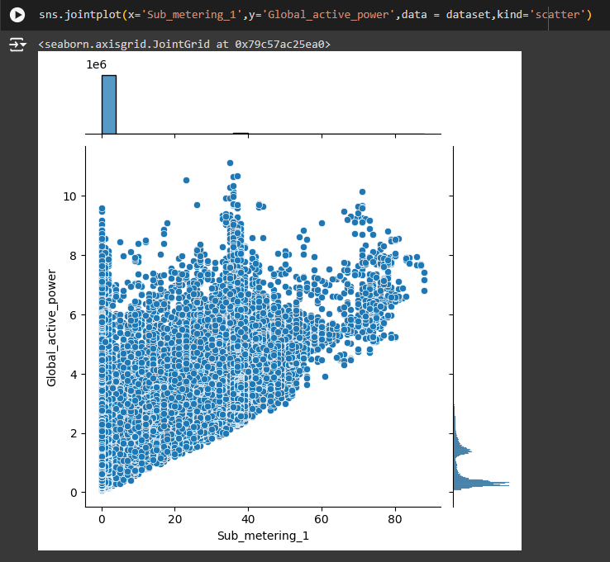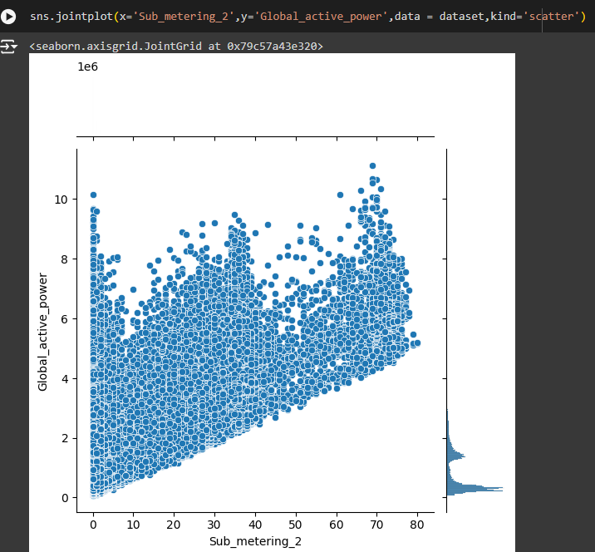

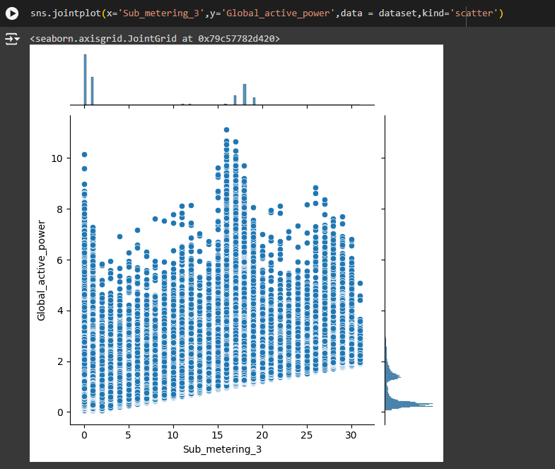

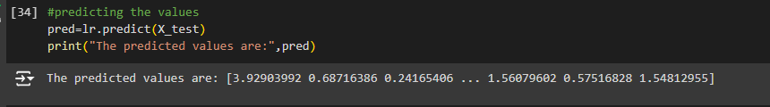

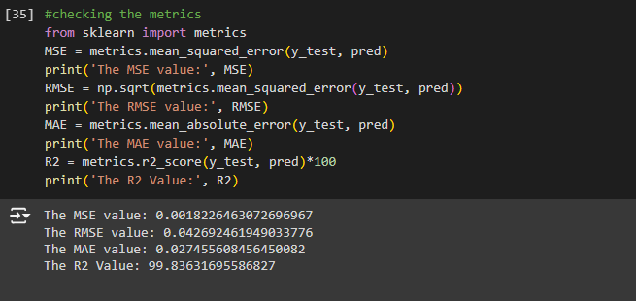

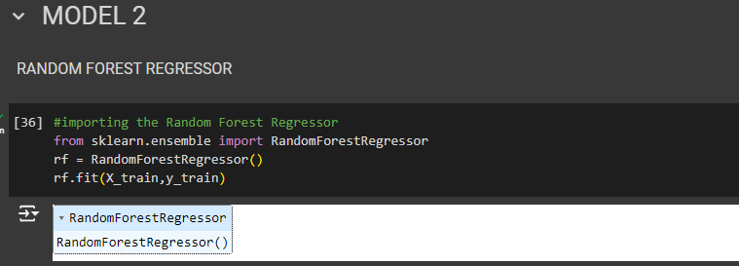

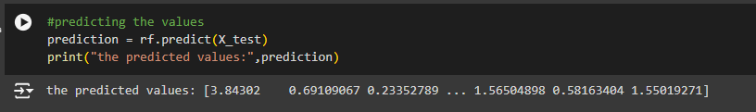

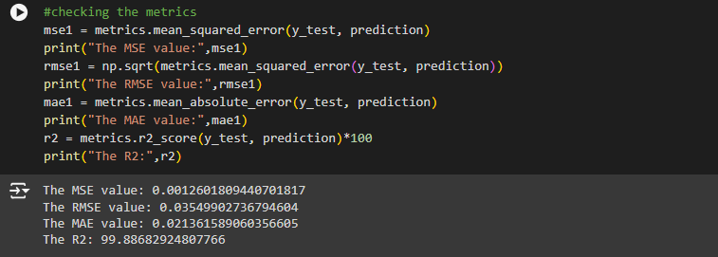

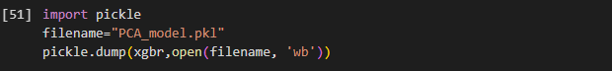

**PCA.HTML:**

<!DOCTYPE html>

<html lang="en">

<head>

<meta charset="UTF-8">

<link rel="icon" type="image/x-icon" href="{{url_for('static',filename='pow.png')}}">

<meta name="viewport" content="width=device-width, initial-scale=1.0">

<title>Power Consumption Analysis</title>

<style>

body {

background-image: url('{{ url_for('static', filename='output.jpg') }}');

background-size: cover;

margin: 1%;

height: 100vh;

display: flex;

align-items: center;

justify-content: center;

font-family: Arial, sans-serif;

}

.navbar {

width: 100%;

overflow: hidden;

background-color: #333;

position: absolute;

top: 0;

}

.navbar a {

float: left;

display: block;

color: white;

text-align: center;

padding: 14px 20px;

text-decoration: none;

font-size: 30px;

cursor: pointer;

}

.navbar a:hover {

background-color: #ddd;

color: black;

}

.about {

text-align: center;

background-color: rgba(12, 1, 0, 0.3);

padding: 20px;

border-radius: 10px;

box-shadow: 0 0 10px rgba(0, 0, 0, 0.1);

margin: 10px;

margin-top: 10px;

align-items: center;

display: none; /* Initially hidden */

justify-content: center;

transition: box-shadow 0.3s;

}

.form-container {

background-color: rgba(255, 255, 255, 0.6);

backdrop-filter: blur(10px);

padding: 20px;

border-radius: 10px;

box-shadow: 0 4px 8px rgba(0, 0, 0, 0.2);

display: inline-block;

flex-direction: column;

justify-content: left;

align-items: left;

width: 500px;

}

.about.active, .form-container.active {

display: inline-block; /* Display only active sections */

}

label {

text-align: center;

font-size: 24px;

color: #000;

margin-bottom: 20px;

}

.form-group {

width: 100%;

margin-bottom: 15px;

}

label {

display: block;

margin-bottom: 5px;

}

input {

width: 100%;

padding: 10px;

box-sizing: border-box;

border-radius: 5px;

border: 1px solid #ccc;

font-size: 16px;

}

button {

outline: 0;

border: 0;

background-color: darkred;

color: white;

width: 100px;

height: 20px;

border-radius: 6px;

cursor: pointer;

margin-top: 10px;

}

.about h2 {

font-size: 3em;

margin-bottom: 20px;

color: black;

}

.about p {

color: white;

font-size: 1.2em;

line-height: 1.6;

}

</style>

</head>

<body>

<nav class="navbar">

<a href="/">Home</a>

<a onClick="showSection('about')">About</a>

</nav>

<div class="about" id="about">

<h2>About Power Consumption Analysis</h2>

<p>

The Power Consumption Analysis project aims to provide households with valuable insights into their energy usage patterns. By analyzing the power consumption data, we can identify areas where energy is being used inefficiently and suggest practical measures to optimize energy use.

</p>

<p>

The ultimate goal of Power Consumption Analysis is to empower households with the knowledge and tools they need to manage their energy consumption effectively. By making informed decisions, households can achieve significant cost savings and contribute to the broader effort of energy conservation.

</p>

</div>

<div class="form-container">

<label><b>Power Consumption Analysis</b></label>

<form action="./predict" method="POST">

<input type="text" name="Global Reactive Power" id="reactive-power" placeholder="Enter the Global reactive power value between 0-1">

<br><br>

<input type="text" id="intensity" name="Global Intensity" placeholder="Enter the Global intensity value">

<br><br>

<input type="text" id="reading1" name="Submeter Reading 1" placeholder="Enter the Submeter Reading1">

<br><br>

<input type="text" id="reading2" name="Submeter Reading 2" placeholder="Enter the Submeter Reading2">

<br><br>

<input type="text" id="reading3" name="Submeter Reading 3" placeholder="Enter the Submeter Reading3">

<br><br>

<button type="submit" class="mybutton">Predict</button>

</form>

</div>

<script>

function showSection(section) {

const sections = document.querySelectorAll('.about, .form-container');

sections.forEach(sec => sec.classList.remove('active'));

document.getElementById(section).classList.add('active');

}

</script>

</body>

</html>

**Result.html:**

<!DOCTYPE html>

<html lang="en">

<head>

<meta charset="UTF-8">

<link rel="icon" type="image/x-icon" href="{{ url_for('static', filename='pow.png') }}">

<meta name="viewport" content="width=device-width, initial-scale=1.0">

<title>Power Consumption Analysis</title>

<style>

@keyframes fadeIn {

from {

opacity: 0;

}

to {

opacity: 1;

}

}

body {

margin: 0;

padding: 0;

background-image: url('{{ url_for('static', filename='output.jpg') }}');

backdrop-filter: blur(2px);

font-family: 'serif';

background-position: center;

background-size: cover;

background-repeat: no-repeat;

display: flex;

flex-direction: column;

justify-content: center;

align-items: center;

height: 100vh;

animation: fadeIn 2s;

}

.navbar {

width: 100%;

overflow: hidden;

background-color: #333;

position: absolute;

top: 0;

height: 65px;

}

.navbar a {

float: left;

display: block;

color: white;

text-align: center;

padding: 14px;

text-decoration: none;

font-size: 30px;

transition: background-color 0.3s, color 0.3s;

cursor: pointer;

}

.navbar a:hover {

background-color: #ddd;

color: black;

}

.container, .about, .precautions {

text-align: center;

background-color: rgba(12, 1, 0, 0.3);

padding: 20px;

border-radius: 10px;

box-shadow: 0 0 10px rgba(0, 0, 0, 0.1);

margin: 10px;

margin-top: 10px;

align-items: center;

display: none; /* Initially hidden */

justify-content: center;

transition: box-shadow 0.3s;

}

.container.active, .about.active, .precautions.active {

display: inline-block; /* Display only active sections */

}

.title {

font-size: 2em;

margin-bottom: 0px;

color: white;

animation: fadeIn 2s;

}

.result-box {

background-color: white;

padding: 10px;

border-radius: 12px;

font-size: 10px;

box-shadow: 0 0 10px rgba(0, 0, 0, 0.2);

text-align: center;

display: inline-block;

margin-top: 10px;

animation: fadeIn 3s;

}

.result-box p {

font-size: 3.0em;

font-family: 'serif';

}

.about h2, .precautions h2 {

font-size: 3em;

margin-bottom: 20px;

color:black;

}

.about p {

color: white;

font-size: 1.2em;

line-height: 1.6;

}

.precautions ul {

color: white;

list-style-type: disc;

padding-left: 20px;

font-size: 1.2em;

}

</style>

</head>

<body>

<div class="navbar">

<a href="/">Home</a>

<a onclick="showSection('about')">About</a>

<a onclick="showSection('precautions')">Precautions</a>

</div>

<div class="container active" id="home">

<div class="title"><b>Power Consumption Analysis</b></div>

<div class="result-box"><p>The Global Active Power Consumed is {{ prediction_text }}</p></div>

</div>

<div class="about" id="about">

<h2>About Power Consumption Analysis</h2>

<p>

The Power Consumption Analysis project aims to provide households with valuable insights into their energy usage patterns. By analyzing the power consumption data, we can identify areas where energy is being used inefficiently and suggest practical measures to optimize energy use.

</p>

<p>

The ultimate goal of Power Consumption Analysis is to empower households with the knowledge and tools they need to manage their energy consumption effectively. By making informed decisions, households can achieve significant cost savings and contribute to the broader effort of energy conservation.

</p>

</div>

<div class="precautions" id="precautions">

<h2>Precautions for Reducing Power Consumption</h2>

<ul>

<li>Use energy-efficient appliances and lighting.</li>

<li>Turn off appliances and lights when not in use.</li>

<li>Unplug devices that are not frequently used.</li>

<li>Regularly maintain heating and cooling systems.</li>

<li>Insulate your home to reduce heating and cooling needs.</li>

<li>Use natural light during the day instead of artificial lighting.</li>

<li>Set your thermostat to an energy-saving temperature.</li>

<li>Use cold water for laundry whenever possible.</li>

<li>Air dry clothes instead of using a dryer.</li>

<li>Perform regular energy audits to identify inefficiencies.</li>

</ul>

</div>

<script>

function showSection(section) {

const sections = document.querySelectorAll('.container, .about, .precautions');

sections.forEach(sec => sec.classList.remove('active'));

document.getElementById(section).classList.add('active');

}

</script>

</body>

</html>

**App.py:**

from flask import Flask, request, render_template

import pandas as pd

import numpy as np

import pickle

app = Flask(__name__)

model = pickle.load(open('PCA_model.pkl', 'rb'))

@app.route('/')

def home():

return render_template("pca.html")

@app.route('/predict', methods=['POST', 'GET'])

def predict():

input_features = [float(x) for x in request.form.values()]

features_name = ['Global_reactive_power', 'Global_intensity', 'Sub_metering_1', 'Sub_metering_2', 'Sub_metering_3']

df = pd.DataFrame([input_features], columns=features_name)

output = model.predict(df)

return render_template('result.html', prediction_text=output)

if __name__ == "__main__":

app.run(debug=False)

**10.2 GitHub and project Demo link:**

Github link:[**Click Here**](https://github.com/shivanivanga01/Power-Consumption-Analysis-for-Households/tree/main)

Project Demo link: **Click Here**